HOLLAND STUDIOof _{photography}
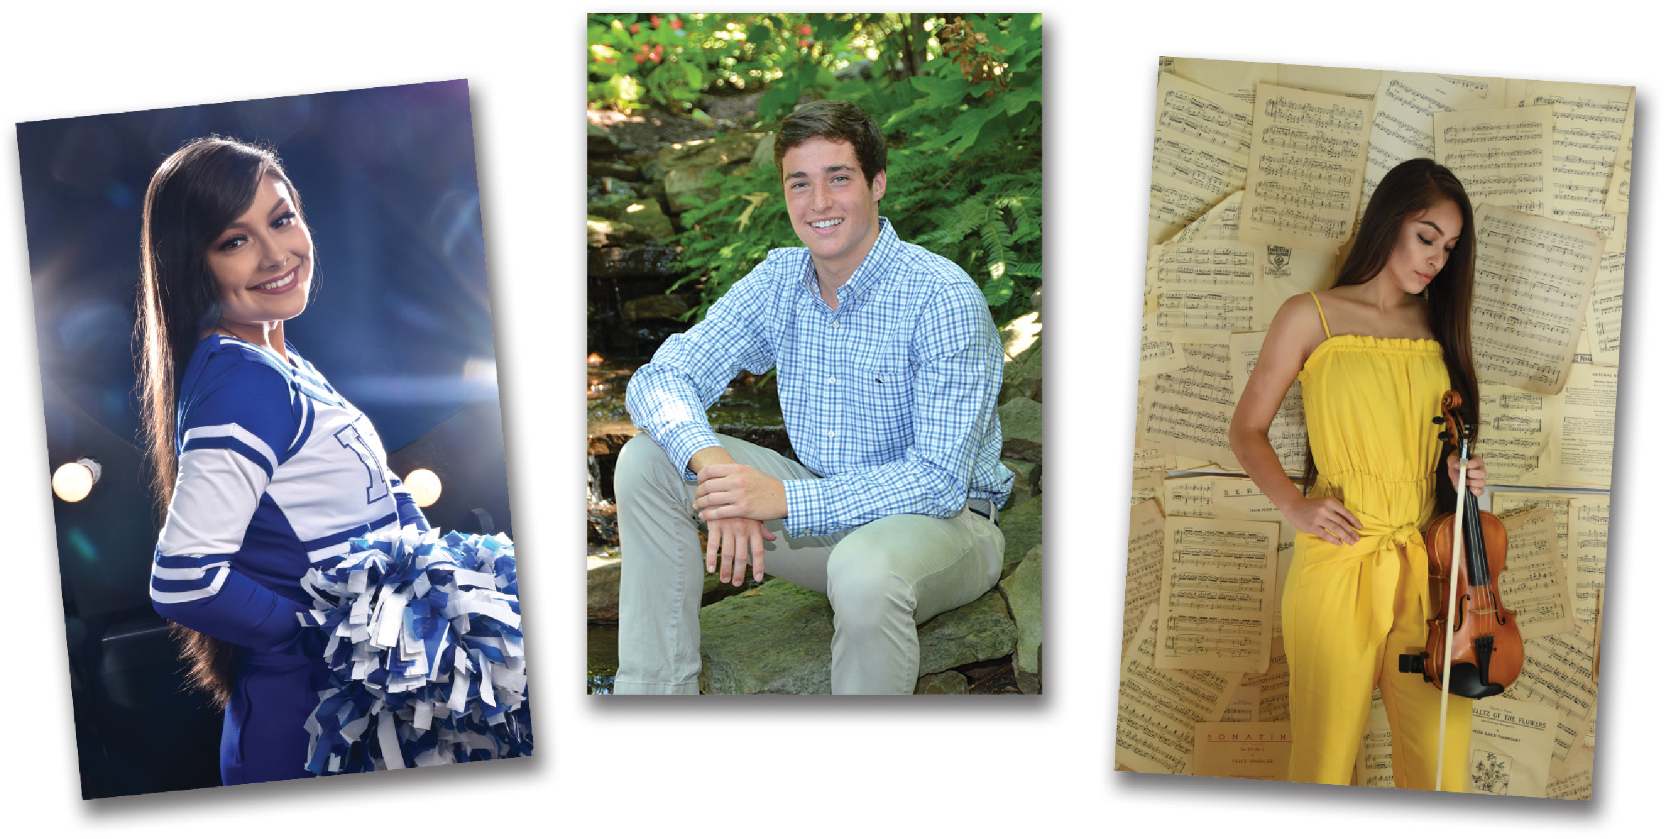
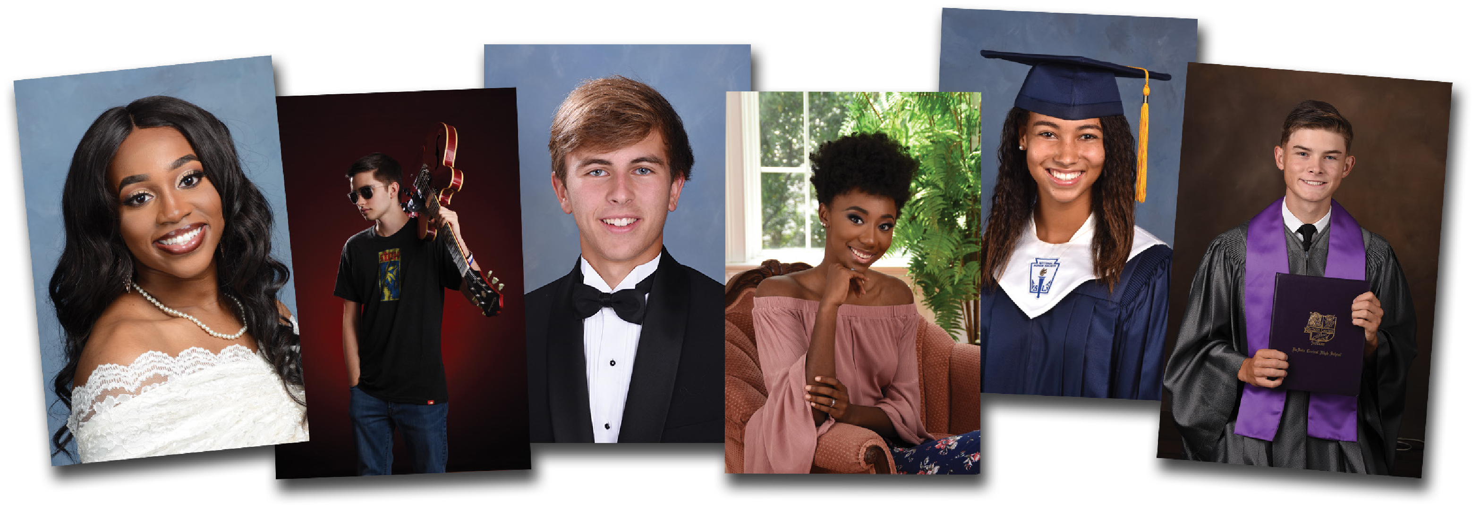
THE Basic First, everything you need for the yearbook!We provide tuxedos, drapes, caps, and gowns. $5495 Plus, be photographed in a casual outfit of your choice.

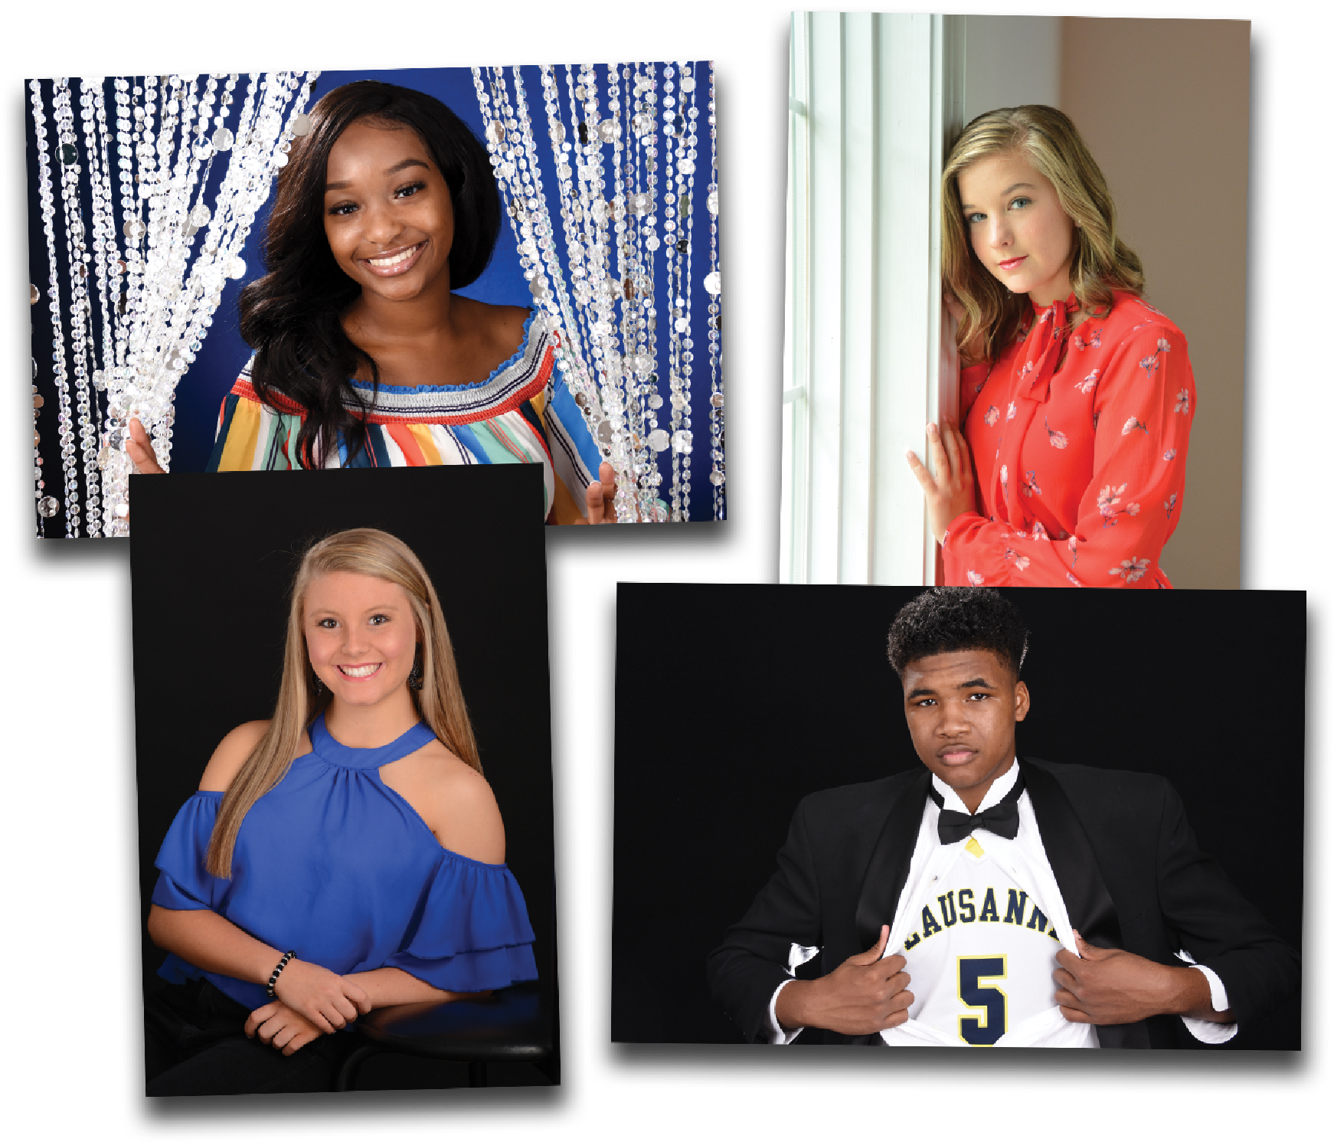
THE Indoor Casual
These sessions are about outfits.
Add the Indoor Casual session to The Basic and have 3 to 4
poses taken in a second outfit of your choice.
Bring your cheerleader or athletic uniform, favorite dress,
or prop and express yourself!
$1500 each
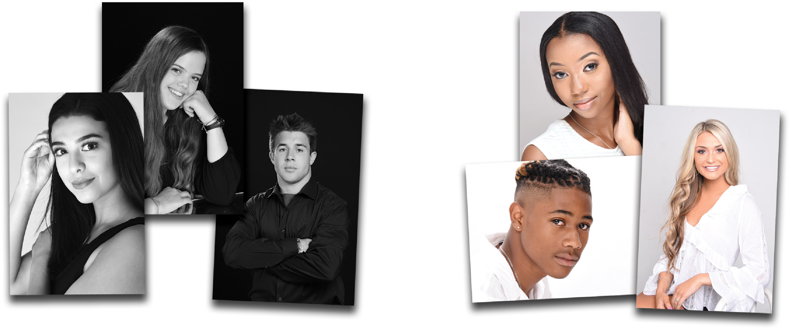
Bring out your
personality in these
two close-up sessions
accentuating the beauty
of black & white and the
color white on white.
This high contrast black & white session
works best with a black shirt or blouse.
This high key color session works
best with a white shirt or blouse.
THE

Black

&
White
THE

White

on
White
$
15
00
$
15
00

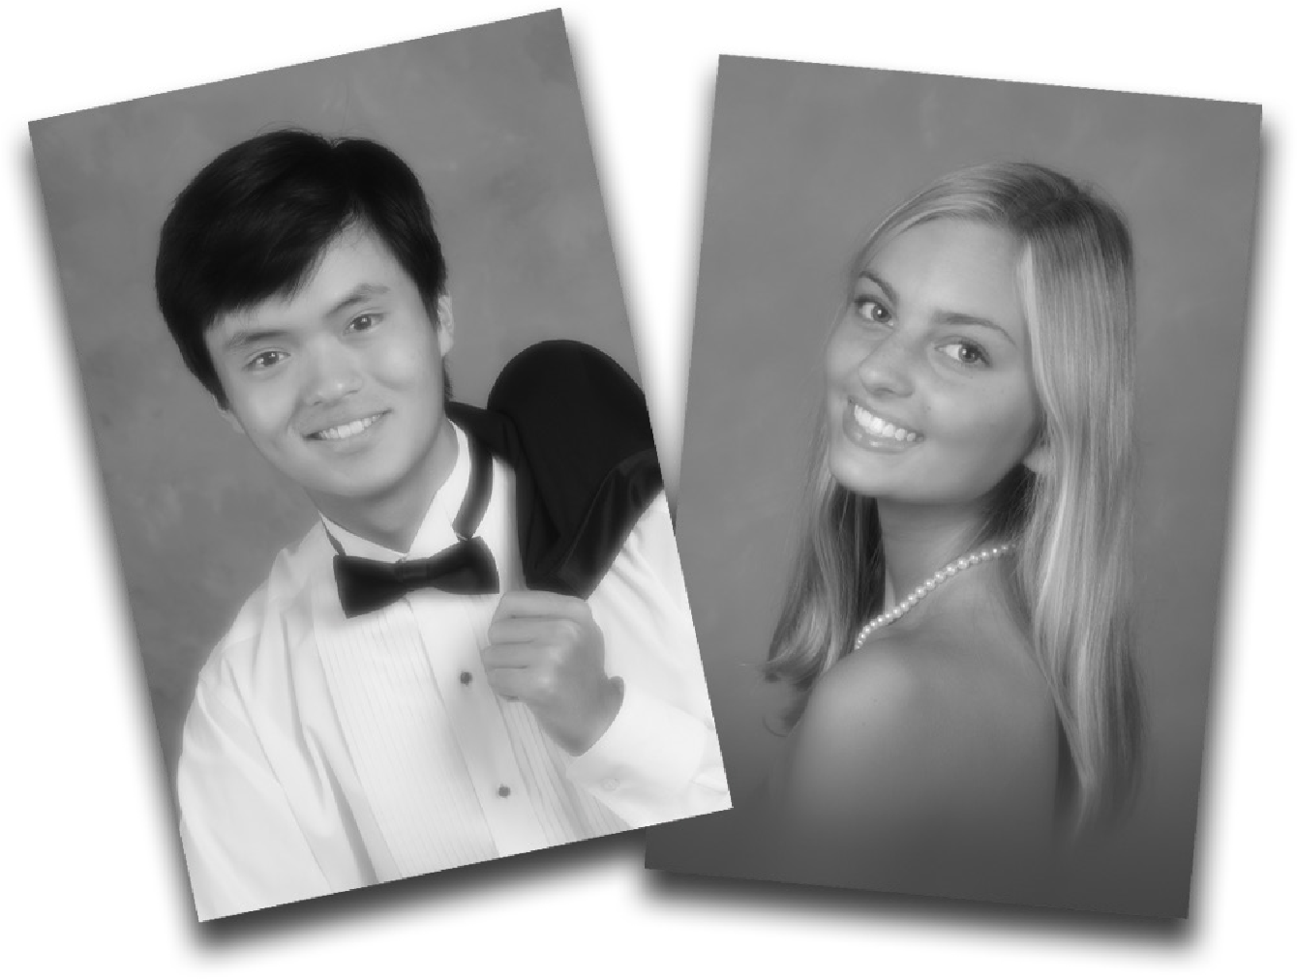
THE Classic
This is a soft focus black and white sitting that captures the timeless beauty of traditional portraiture. This sitting remains a constant
favorite of parents and students alike.
$1500

^{THE} Digital Creation Session
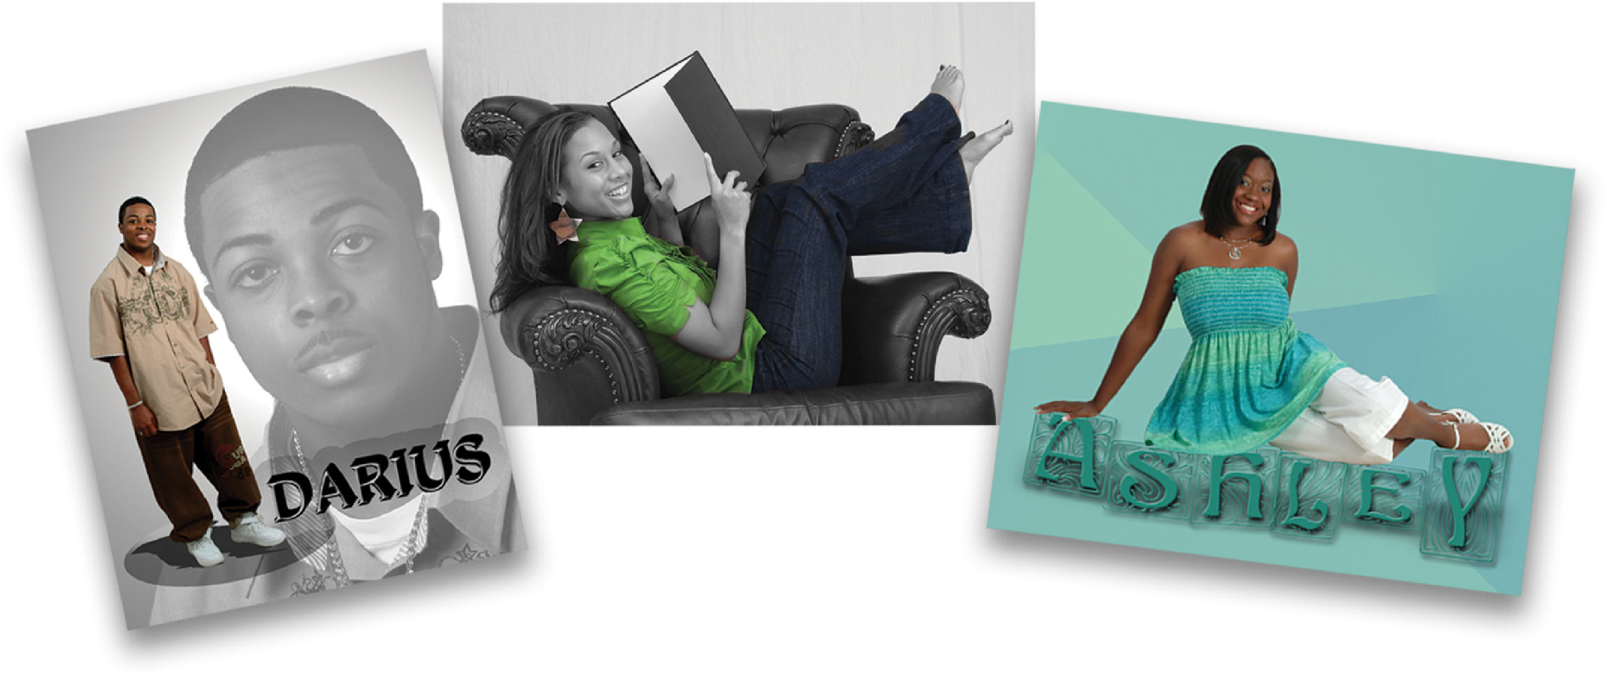
$
49
95
$
15
00
SITTING FEE
SETUP FEE

^{THE} Environmental
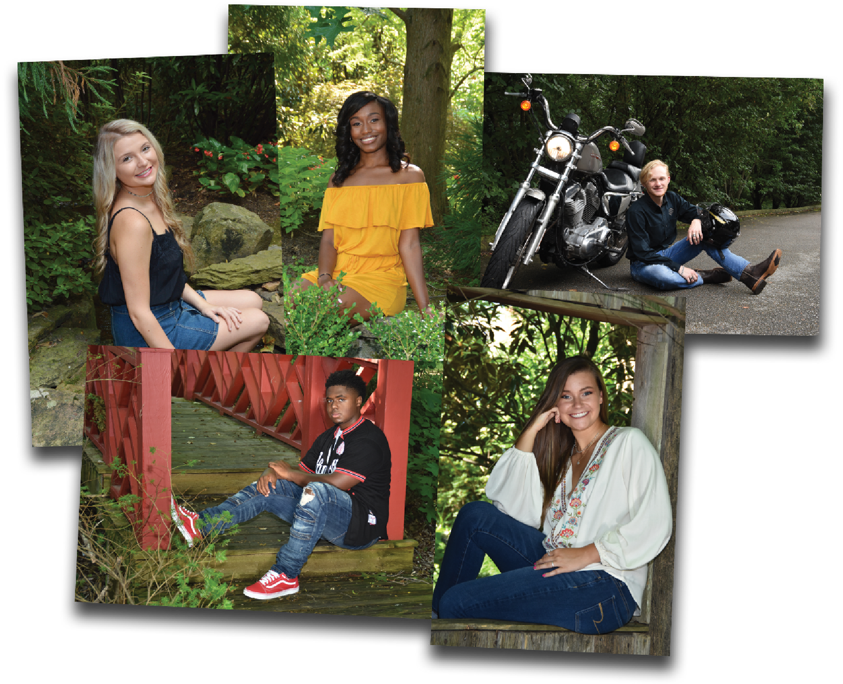
Our beautiful outdoor portrait park offers you photographic opportunities with a mountain creek, classic rope
swing, rustic barn, or Southern white
porch. Our azaleas, waterfalls, and split rail fences are waiting for you!
Sessions are limited, so book this popular sitting early! Important: Please inform our office of any special props
(cars, etc.) you are bringing, as special times and locations must be booked.
$3000

HOLLAND STUDIO ^{of} photography
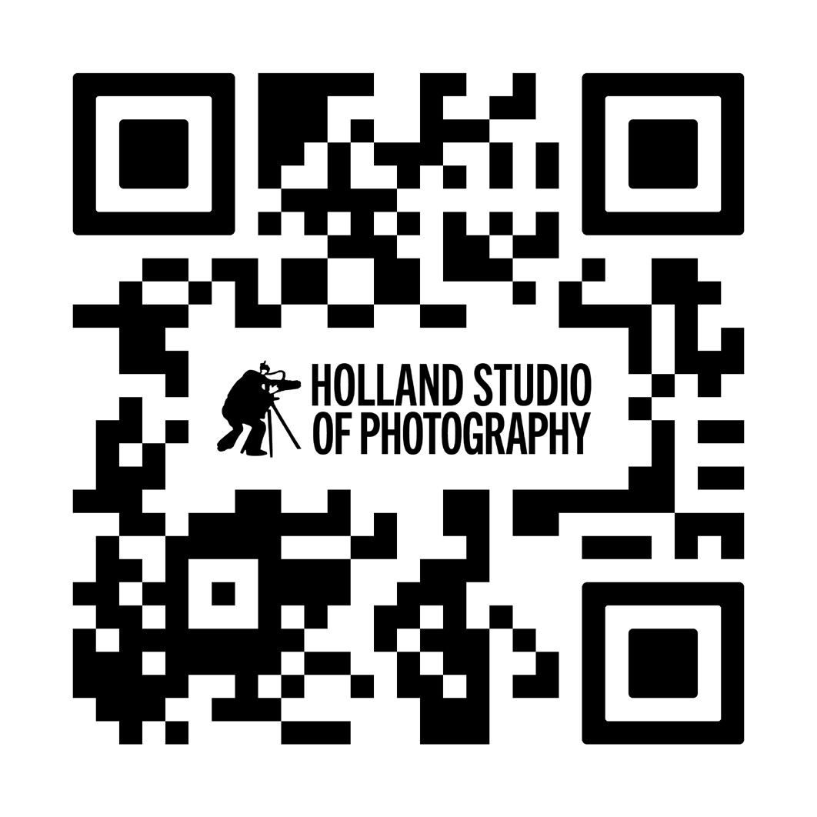
Call now to make your appointment! (901) 362-1818

